**STR Document**

**The summary of the testing**

[**https://www.wobi.co.il/**](https://www.wobi.co.il/)



**website**

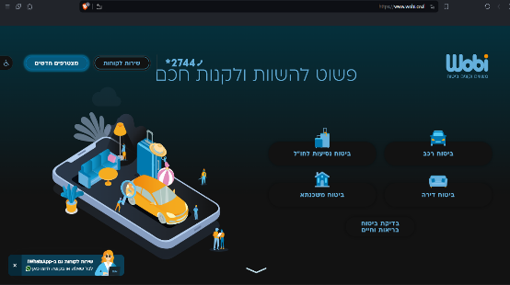

**created by Tanya Hass**



**Content**

Application Overview 5

Test Cases and Bugs Statuses 6

Recomendations 9

Conclusion 10

Bugs List 11

Bug Reports 13



Application Overview

This document presents findings referring to the tests done on **the website of Wobi**

(https://www.wobi.co.il/).

The website Wobi is a website that compares insurance prices online and allows online purchase of insurance policies. The site provides services in the financial and insurance fields, including car insurance, home insurance, travel insurance abroad, pensions, loan comparison and finding lost funds. The site works in collaboration with insurance companies in Israel and mediates between the insured and the insurance companies.

The tests were executed on all of the functionality of the site, including the site navigation, execution of the main functionality, links and documents, also reading the presented information about the company's products, GUI testing, etc.



Test Cases and Bugs Statuses

(Metrics)

**Test Cases - Status**

|  |  |  |  |
| --- | --- | --- | --- |
| Passed | Failed | Not run | Total |
| 832 | 28 | 40 | 900 |



**Bugs Severity - Status**

|  |  |  |  |  |
| --- | --- | --- | --- | --- |
| S1 - Showstopper | S2 - Critical | S3 - Major | S4 - Minor | S5 - Low |
| 0 | 1 | 5 | 3 | 19 |

**Bugs Priority – Status**

|  |  |  |  |
| --- | --- | --- | --- |
| Critical | High | Medium | Low |
| 1 | 5 | 15 | 7 |

**Defect Distribution**

|  |  |  |  |  |  |  |  |  |
| --- | --- | --- | --- | --- | --- | --- | --- | --- |
| Severity | דף כניסה - footer | שירות לקוחות | מצטרפים חדשים | ביטוח רכב | ביטוח דירה | ביטוח נסיעות לחו"ל | פנסיה | Total |
| S1 - Show Stopper |  |  |  |  |  |  |  | **0** |
| S2 - Critical |  |  |  |  |  |  | 1 | **1** |
| S3 - Major |  | 1 |  | 4 |  |  |  | **5** |
| S4 - Minor |  | 1 |  |  | 2 |  |  | **3** |
| S5 - Low | 6 | 4 | 3 | 2 | 1 | 3 |  | **19** |
| Total | **6** | **6** | **3** | **6** | **3** | **3** | **1** | **28** |



Recommendations

* **Security in the "name" field**:
  + The "name" field should be secure to prevent users from entering too long name (there is diapason of maximum length of the field which is 64-300 characters including spaces in between).
  + The "name" field should be secure to prevent users from entering a name including only spaces.
* **Spelling of the "התקשרו אליי" button**:

The "call me" button should be spelled correctly. In some places on the site, it spelled "התקשרו אלי", in others "התקשרו אליי"

* **Outdated links**:

Outdated links should be edited or removed. Outdated links lead users to pages that no longer exist, which can be frustrating and confusing.

* **Misleading buttons and objects**:

Buttons and objects that are misleading should be fixed. For example, a Dropbox that includes only 1 option or the button "מצאו כספים אבודים" that seems to be something like a service or a form to contact a representative that will help you to find the money, but actually it only sends you back to an article.



Conclusion

**Testing of the insurance company website revealed a total of 28 bugs, with varying severity levels.**

**The majority (19) were classified as low Severity, indicating a good foundation for functionality.**

**There was no any defect classified as Show Stopper, there is only one defect classified as Critical Severity.**

**However, it's crucial to address the higher severity issues to ensure a smooth user experience and potential security risks.**

**Based on the testing results,**

**a release of the https://www.wobi.co.il/ website is recommended.**



Bugs List

WS-1 [Text in the video at the bottom of the main page coming out of the screen](https://tatyanadman.atlassian.net/browse/WS-1)s.

WS-2 [There is an error in the "התקשרו אליי" button inside “מצטרפים חדשים “.](https://tatyanadman.atlassian.net/browse/WS-2)

WS-3 [In menu of 2 options the links send to the same site.](https://tatyanadman.atlassian.net/browse/WS-3)

WS-4 [In the "....הקליקו על הלינק" section the links of the "שומרה" company are broken.](https://tatyanadman.atlassian.net/browse/WS-4)

WS-5 [There is an error in the "התקשרו אליי" button inside “מעוניינים לקבל שיחה מנציג?“ form at the home page.](https://tatyanadman.atlassian.net/browse/WS-5)

WS-6 [There is an error in the "התקשרו אליי" button inside “ביטוח דירה“.](https://tatyanadman.atlassian.net/browse/WS-6)

WS-7 [A link is partially placed under a button.](https://tatyanadman.atlassian.net/browse/WS-7)

WS-8  [Inside "ביטוח דירה" in the articles “כמה טיפים לפני שקונים“ in Dark Mode the text is very difficult to read because of pictures under the text.](https://tatyanadman.atlassian.net/browse/WS-8)

WS-9 [Dropbox with only 1 option inside "הורדת טפסים" of "שירות לקוחות".](https://tatyanadman.atlassian.net/browse/WS-9)

WS-10 [The phone number *2744 is not active and not highlighted at an article.](https://tatyanadman.atlassian.net/browse/WS-10)

WS-11 [The phone number 077-6001000 is not clickable and not highlighted at an article.](https://tatyanadman.atlassian.net/browse/WS-11)

WS-12 [Under "הורדת טפסים" a text right down logos of insurance companies seems to be clickable but it's not.](https://tatyanadman.atlassian.net/browse/WS-12)

WS-13 [The option “ביטוח נסיעות לחו”ל“ doesn’t appear at the drop box in the form under "?מעוניינים לקבל שיחה מנציג".](https://tatyanadman.atlassian.net/browse/WS-13)

WS-14 [The field "שם מלא" doesn't limit the number of characters that can be entered.](https://tatyanadman.atlassian.net/browse/WS-14)

WS-15 [The "שם מלא" field except a "name" consist of only spaces.](https://tatyanadman.atlassian.net/browse/WS-15)

WS-16 [There is no space between 2 words in the article "...הסחות דעת בזמן הנהיגה".](https://tatyanadman.atlassian.net/browse/WS-16)

WS-17 [Only a portion of the "צרו קשר" form is visible after clicking the link.](https://tatyanadman.atlassian.net/browse/WS-17)



WS-18 [Misleading "מצאו כספים אבודים" Button Navigation.](https://tatyanadman.atlassian.net/browse/WS-18)

WS-19 ["פנסיה" Link in Footer Leads to 502 Bad Gateway Error](https://tatyanadman.atlassian.net/browse/WS-19).

WS-20 [Text Contrast Issue in Dark Mode Articles ("ביטוח רכב")](https://tatyanadman.atlassian.net/browse/WS-20).

WS-21 [There is a part of a list that separated from the rest of the text (ביטוח רכב -> שאלות ותשובות).](https://tatyanadman.atlassian.net/browse/WS-21)

WS-22 [The "מהיום" radio button is not functioning as expected (ביטוח רכב -> מקיף + חובה).](https://tatyanadman.atlassian.net/browse/WS-22)

WS-23 [Car brand search limited to Hebrew letters.](https://tatyanadman.atlassian.net/browse/WS-23)

WS-24 [In the "יצרן" section the list of car brands is not complete (ביטוח רכב).](https://tatyanadman.atlassian.net/browse/WS-24)

WS-25 [Inaccurate error message in travel insurance end date field](https://tatyanadman.atlassian.net/browse/WS-25).

WS-26 [Spelling error in "לאו קוסט" inside "ביטוח כבודה ב-2023" of the section "ביטוח נסיעות לחו"ל".](https://tatyanadman.atlassian.net/browse/WS-26)

WS-27 [Font failure at the footer.](https://tatyanadman.atlassian.net/browse/WS-27)

WS-28 [There is unclear (unknown) direction in the section "תאריכים ויעד" of "ביטוח נסיעות לחו"ל".](https://tatyanadman.atlassian.net/browse/WS-28)



Bug Reports

|  |  |
| --- | --- |
| [WS-1] Text in the video at the bottom of the main page coming out of the screen. Created: 04/Mar/24  Updated: 05/Mar/24 | |
| **Status:** | To Do |
| **Project:** | [Wobi_site](https://tatyanadman.atlassian.net/secure/BrowseProject.jspa?id=10004) |

|  |  |  |  |
| --- | --- | --- | --- |
| **Type:** | Bug | **Priority:** | Low |
| **Reporter:** | [Tatyana](https://tatyanadman.atlassian.net/secure/ViewProfile.jspa?accountId=626cfc5bb31e6f006864ef5b) | **Assignee:** | Unassigned |
| **Resolution:** | Unresolved | **Votes:** | 0 |
| **Environment:** | Environment Desktop: Asus Vivobook.  OS: Windows 11.  Browser: Brave  Version: 1.61.109 | | |
|  |  | | |
|  |  | | |
|  |  | | |

|  |  |
| --- | --- |
| **Attachments:** | p2.png |
| **Severity:** | S5 - Low |



|  |  |
| --- | --- |
| **Description** |  |

|  |
| --- |
| **Steps to Reproduce:**   1. Go to the site [www.wobi.co.il](https://www.wobi.co.il/) . 2. Scroll down to the video at the bottom of the page.. 3. Check out the text on the video (from left side).   **Actual Result:**  The logo of the company is cut on the video.  **Expected Result:**  The video should fit the sizes of the page. |

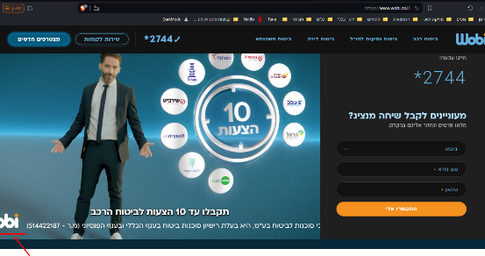



|  |  |  |  |
| --- | --- | --- | --- |
| [WS-2] There is an error in the "התקשרו אליי" button inside “מצטרפים חדשים“. Created: 05/Mar/24  Updated: 05/Mar/24 | | | |
| **Status:** | To Do | | |
| **Project:** | [Wobi_site](https://tatyanadman.atlassian.net/secure/BrowseProject.jspa?id=10004) | | |
| **Type:** | Bug | **Priority:** | Medium |
| **Reporter:** | [Tatyana](https://tatyanadman.atlassian.net/secure/ViewProfile.jspa?accountId=626cfc5bb31e6f006864ef5b) | **Assignee:** | Unassigned |
| **Resolution:** | Unresolved | **Votes:** | 0 |
| **Environment:** | Desktop: Asus Vivobook.  OS: Windows 11.  Browser: Brave  Version: 1.61.109 | | |

|  |  |
| --- | --- |
| **Attachments:** | p3.png |
| **Severity:** | S5 - Low |

|  |  |
| --- | --- |
| **Description** |  |

|  |
| --- |
| **Steps to Reproduce:**   1. Go to the site [www.wobi.co.il](https://www.wobi.co.il/) . 2. Press the “מצטרפים חדשים“ button. 3. In the appeared form look at the “התקשרו אלי“ button.   **Actual Result:**  It is written “התקשרו אלי“.  **Expected Result:**  It should be written "התקשרו אליי”. |

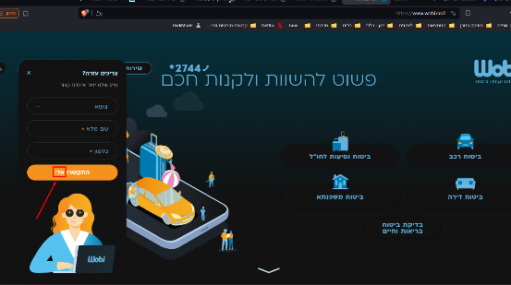



|  |  |  |  |
| --- | --- | --- | --- |
| [WS-3] In menu of 2 options the links send to the same site. Created: 05/Mar/24  Updated: 05/Mar/24 | | | |
| **Status:** | To Do | | |
| **Project:** | [Wobi_site](https://tatyanadman.atlassian.net/secure/BrowseProject.jspa?id=10004) | | |
| **Type:** | Bug | **Priority:** | Low |
| **Reporter:** | [Tatyana](https://tatyanadman.atlassian.net/secure/ViewProfile.jspa?accountId=626cfc5bb31e6f006864ef5b) | **Assignee:** | Unassigned |
| **Resolution:** | Unresolved | **Votes:** | 0 |
| **Labels:** | None | | |
| **Environment:** | Desktop: Asus Vivobook.  OS: Windows 11.  Browser: Brave  Version: 1.61.109 | | |
| **Attachments:** | p4.png     p5.png     p6.png     p7.png     p8.png | | |
| **Severity:** | S5 - Low | | |

|  |  |
| --- | --- |
| **Description** |  |

|  |
| --- |
| **Steps to Reproduce:**   1. Go to the site [www.wobi.co.il](https://www.wobi.co.il/) . 2. Press the “שירות לקוחות“ button. 3. Scroll down to the “…הקליקו על הלינק“. 4. Set mouse cursor on the logo of any company. 5. In the appeared menu press the first option “בחרו מוסך הסדר“. 6. Then press the second option “בחרו שמאי“. 7. Compare the opened pages.   **Actual Result:**  The links send to the same page.  **Expected Result:**  It should be first page with the options to choose a garage. And the second page to choose an appraiser. |

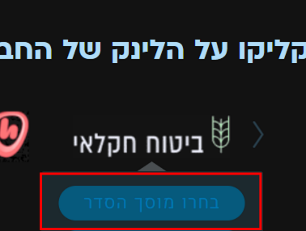

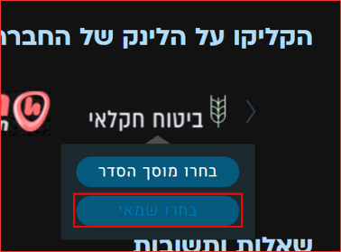

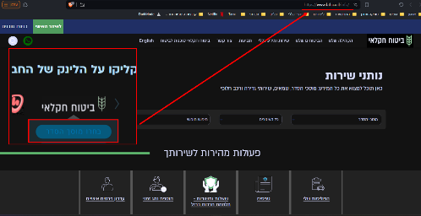

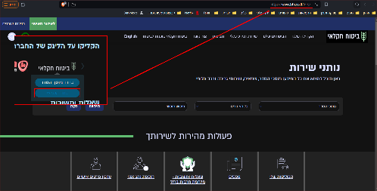



|  |  |  |  |
| --- | --- | --- | --- |
| [WS-4] In the "....הקליקו על הלינק" section the links of the "שומרה" company are broken. Created: 05/Mar/24  Updated: 05/Mar/24 | | | |
| **Status:** | To Do | | |
| **Project:** | [Wobi_site](https://tatyanadman.atlassian.net/secure/BrowseProject.jspa?id=10004) | | |
| **Type:** | Bug | **Priority:** | High |
| **Reporter:** | [Tatyana](https://tatyanadman.atlassian.net/secure/ViewProfile.jspa?accountId=626cfc5bb31e6f006864ef5b) | **Assignee:** | Unassigned |
| **Resolution:** | Unresolved | **Votes:** | 0 |
| **Environment:** | Environment Desktop: Asus Vivobook.  OS: Windows 11.  Browser: Brave  Version: 1.61.109 | | |
| **Attachments:** | p10.png     p11.png     p9.png | | |
| **Severity:** | S3 - Major | | |

|  |  |
| --- | --- |
| **Description** |  |

|  |
| --- |
| **Steps to Reproduce:**   1. Go to the site [www.wobi.co.il](https://www.wobi.co.il/) . 2. Press the “שירות לקוחות“ button. 3. Scroll down to the “…הקליקו על הלינק“. 4. Set mouse cursor on the logo of the “שומרה“ company. 5. In the appeared menu press the first option “בחרו מוסך הסדר“. 6. Then press the second option “בחרו שמאי“.   **Actual Result:**  The links are broken and send to non-existent pages.  **Expected Result:**  The links send to 2 different pages where you can choose a garage or an appraiser. |

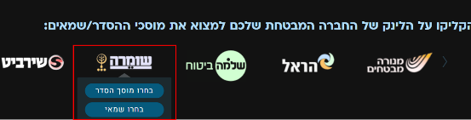

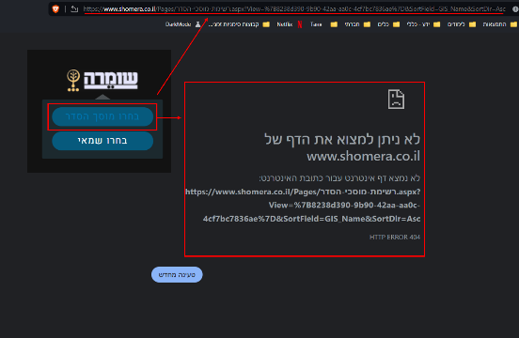

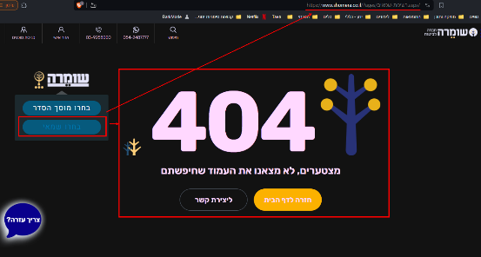



|  |  |  |  |
| --- | --- | --- | --- |
| [WS-5] There is an error in the "התקשרו אליי" button inside “מעוניינים לקבל שיחה מנציג?“ form at the home page. Created: 08/Mar/24  Updated: 13/Mar/24 | | | |
| **Status:** | To Do | | |
| **Project:** | [Wobi_site](https://tatyanadman.atlassian.net/secure/BrowseProject.jspa?id=10004) | | |
| **Type:** | Bug | **Priority:** | Medium |
| **Reporter:** | [Tatyana](https://tatyanadman.atlassian.net/secure/ViewProfile.jspa?accountId=626cfc5bb31e6f006864ef5b) | **Assignee:** | Unassigned |
| **Resolution:** | Unresolved | **Votes:** | 0 |
| **Environment:** | Environment Desktop: Asus Vivobook.  OS: Windows 11.  Browser: Brave  Version: 1.61.109 | | |
| **Attachments:** | p45.png | | |
| **Severity:** | S5 - Low | | |

|  |  |
| --- | --- |
| **Description** |  |

|  |
| --- |
| **Steps to Reproduce:**   1. Go to the site [www.wobi.co.il](https://www.wobi.co.il/) . 2. At the home page scroll down till the form “**מעוניינים לקבל שיחה מנציג?**“. 3. Look at the “התקשרו אלי“ button.   **Actual Result:**  It is written “התקשרו אלי“.  **Expected Result:**  It should be written "התקשרו אליי”. |

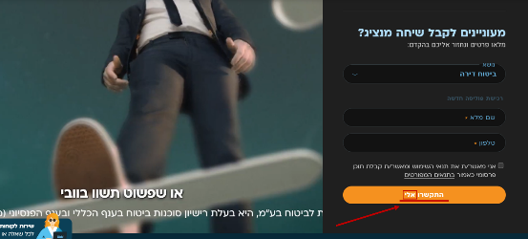



|  |  |  |  |
| --- | --- | --- | --- |
| [WS-6] There is an error in the "התקשרו אליי" button inside “ביטוח דירה“. Created: 08/Mar/24  Updated: 13/Mar/24 | | | |
| **Status:** | To Do | | |
| **Project:** | [Wobi_site](https://tatyanadman.atlassian.net/secure/BrowseProject.jspa?id=10004) | | |
| **Type:** | Bug | **Priority:** | Medium |
| **Reporter:** | [Tatyana](https://tatyanadman.atlassian.net/secure/ViewProfile.jspa?accountId=626cfc5bb31e6f006864ef5b) | **Assignee:** | Unassigned |
| **Resolution:** | Unresolved | **Votes:** | 0 |
| **Environment:** | Desktop: Asus Vivobook.  OS: Windows 11.  Browser: Brave  Version: 1.61.109 | | |
| **Attachments:** | p44.png | | |
| **Severity:** | S5 - Low | | |

|  |  |
| --- | --- |
| **Description** |  |

|  |
| --- |
| **Steps to Reproduce:**   1. Go to the site [www.wobi.co.il](https://www.wobi.co.il/) . 2. Press the “ביטוח דירה“ button. 3. Scroll down till the form “מעדיפים שנציג יחזור אליכם בהקדם?“ 4. Look at the “התקשרו אלי“ button.   **Actual Result:**  It is written “התקשרו אלי“.  **Expected Result:**  It should be written "התקשרו אליי”. |

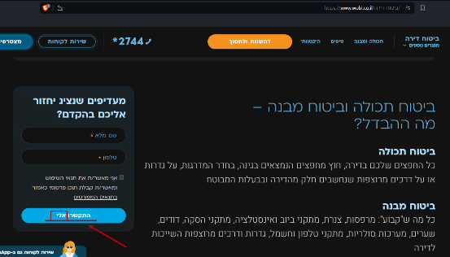



|  |  |  |  |
| --- | --- | --- | --- |
| [WS-7] A link is partially placed under a button. Created: 08/Mar/24  Updated: 13/Mar/24 | | | |
| **Status:** | To Do | | |
| **Project:** | [Wobi_site](https://tatyanadman.atlassian.net/secure/BrowseProject.jspa?id=10004) | | |
| **Type:** | Bug | **Priority:** | Medium |
| **Reporter:** | [Tatyana](https://tatyanadman.atlassian.net/secure/ViewProfile.jspa?accountId=626cfc5bb31e6f006864ef5b) | **Assignee:** | Unassigned |
| **Resolution:** | Unresolved | **Votes:** | 0 |
| **Environment:** | Desktop: Asus Vivobook.  OS: Windows 11.  Browser: Brave  Version: 1.61.109 | | |
| **Attachments:** | p43.png | | |
| **Severity:** | S4 - Minor | | |

|  |  |
| --- | --- |
| **Description** |  |

|  |
| --- |
| **Steps to Reproduce:**   1. Go to the site [www.wobi.co.il](https://www.wobi.co.il/) . 2. Navigate to “ביטוח דירה“. 3. Look at the 3 buttons at the page - ביטוח מבנה + תכולה, ביטוח מבנה, ביטוח תכולה. 4. Look at the link “לא בטוחים מה אתם צריכים? התחילו כאן“ under “ביטוח תכולה“ button.   **Actual Result:**  The button covered the link partially.  **Expected Result:**  There should be space between elements on the page. |

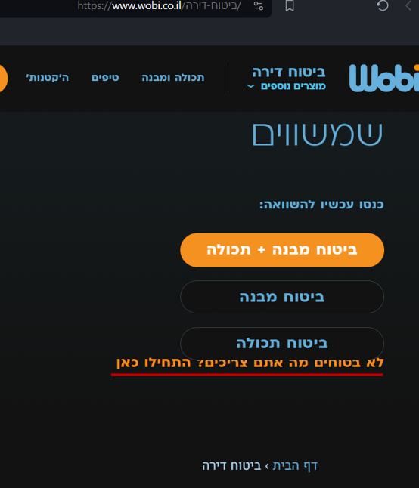



|  |  |  |  |
| --- | --- | --- | --- |
| [WS-8]  Inside "ביטוח דירה" in the articles “כמה טיפים לפני שקונים“ in Dark Mode the text is very difficult to read because of pictures under the text. Created: 08/Mar/24  Updated: 13/Mar/24 | | | |
| **Status:** | To Do | | |
| **Project:** | [Wobi_site](https://tatyanadman.atlassian.net/secure/BrowseProject.jspa?id=10004) | | |
| **Type:** | Bug | **Priority:** | Medium |
| **Reporter:** | [Tatyana](https://tatyanadman.atlassian.net/secure/ViewProfile.jspa?accountId=626cfc5bb31e6f006864ef5b) | **Assignee:** | Unassigned |
| **Resolution:** | Unresolved | **Votes:** | 0 |
| **Environment:** | Environment Desktop: Asus Vivobook.  OS: Windows 11.  Browser: Brave  Version: 1.61.109 | | |
| **Attachments:** | p40.png     p41.png     p42.png | | |
| **Severity:** | S4 - Minor | | |

|  |  |
| --- | --- |
| **Description** |  |

|  |
| --- |
| **Steps to Reproduce:**   1. Go to the site [www.wobi.co.il](https://www.wobi.co.il/) with DarkMode. 2. Navigate to “ביטוח דירה“. 3. Scroll down to the “כמה טיפים לפני שקונים“ articles. 4. Look at the text at 1st, 2nd and 3rd articles.   **Actual Result:**  The text is very difficult to read because of pictures under the text.  **Expected Result:**  The text and the pictures under the text should contrast each to other. |

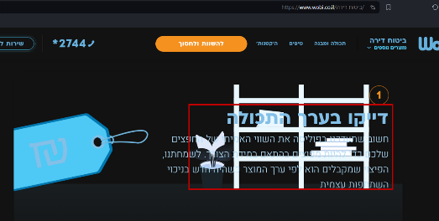

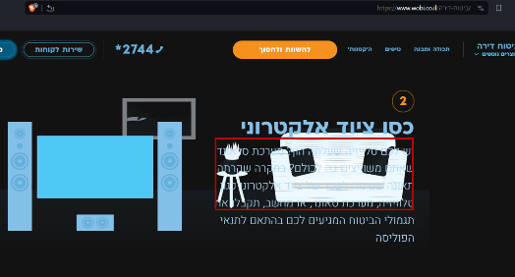

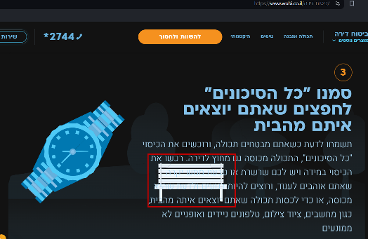



|  |  |  |  |
| --- | --- | --- | --- |
| [WS-9] Dropbox with only 1 option inside "הורדת טפסים" of "שירות לקוחות". Created: 08/Mar/24  Updated: 08/Mar/24 | | | |
| **Status:** | To Do | | |
| **Project:** | [Wobi_site](https://tatyanadman.atlassian.net/secure/BrowseProject.jspa?id=10004) | | |
| **Type:** | Bug | **Priority:** | Lowest |
| **Reporter:** | [Tatyana](https://tatyanadman.atlassian.net/secure/ViewProfile.jspa?accountId=626cfc5bb31e6f006864ef5b) | **Assignee:** | Unassigned |
| **Resolution:** | Unresolved | **Votes:** | 0 |
| **Environment:** | Desktop: Asus Vivobook.  OS: Windows 11.  Browser: Firefox  Version: 123.0.1 (64-bit) | | |
| **Severity:** | S5 - Low | | |
| **Attachments:** | p39.png | | |

|  |  |
| --- | --- |
| **Description** |  |

|  |
| --- |
| **Steps to Reproduce:**   1. Go to the site [www.wobi.co.il](https://www.wobi.co.il/) . 2. Press the “שירות לקוחות“ button at the top of the page. 3. Scroll down to the “הורדת טפסים“ section. 4. Press the drop box “מוצר“. 5. Look at the appeared options.   **Actual Result:**  There is only 1 option inside the drop box.  **Expected Result:**  We expect that in drop box there is a list of options to choose. |

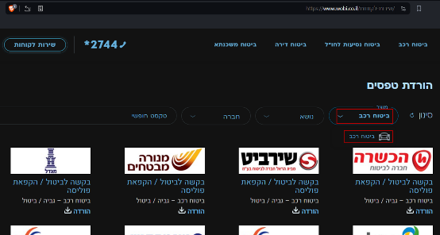



|  |  |  |  |
| --- | --- | --- | --- |
| [WS-10] The phone number *2744 is not active and not highlighted at an article. Created: 08/Mar/24  Updated: 13/Mar/24 | | | |
| **Status:** | To Do | | |
| **Project:** | [Wobi_site](https://tatyanadman.atlassian.net/secure/BrowseProject.jspa?id=10004) | | |
| **Type:** | Improvement | **Priority:** | Medium |
| **Reporter:** | [Tatyana](https://tatyanadman.atlassian.net/secure/ViewProfile.jspa?accountId=626cfc5bb31e6f006864ef5b) | **Assignee:** | Unassigned |
| **Resolution:** | Unresolved | **Votes:** | 0 |
| **Environment:** | Desktop: Asus Vivobook.  OS: Windows 11.  Browser: Firefox  Version: 123.0.1 (64-bit) | | |
| **Attachments:** | p38.png | | |
| **Severity:** | S5 - Low | | |

|  |  |
| --- | --- |
| **Description** |  |

|  |
| --- |
| **Steps to Reproduce:**   1. Go to the site [www.wobi.co.il](https://www.wobi.co.il/) . 2. Navigate to “שירות לקוחות“. 3. Scroll down to “שאלות ותשובות“. 4. Open the question “מה אני נדרש במקרה של תאונה/גניבה“. 5. Look for the number +2744.   **Actual Result:**  The phone number is not clickable and not highlighted unlike other links and numbers in the article.  **Expected Result:**  The phone number should be clickable and highlighted for a user convenience. |

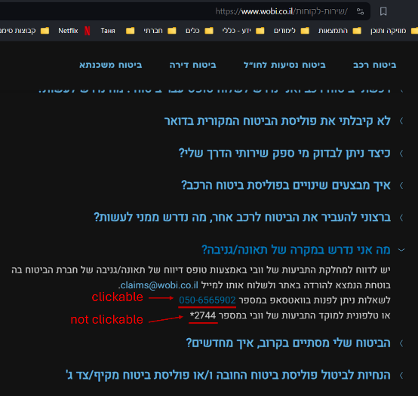



|  |  |  |  |
| --- | --- | --- | --- |
| [WS-11] The phone number 077-6001000 is not clickable and not highlighted at an article. Created: 08/Mar/24  Updated: 13/Mar/24 | | | |
| **Status:** | To Do | | |
| **Project:** | [Wobi_site](https://tatyanadman.atlassian.net/secure/BrowseProject.jspa?id=10004) | | |
| **Type:** | Improvement | **Priority:** | Medium |
| **Reporter:** | [Tatyana](https://tatyanadman.atlassian.net/secure/ViewProfile.jspa?accountId=626cfc5bb31e6f006864ef5b) | **Assignee:** | Unassigned |
| **Resolution:** | Unresolved | **Votes:** | 0 |
| **Attachments:** | p37.png | | |
| **Severity:** | S4 - Minor | | |
| **Environment:** | Desktop: Asus Vivobook.  OS: Windows 11.  Browser: Firefox  Version: 123.0.1 (64-bit) | | |

|  |  |
| --- | --- |
| **Description** |  |

|  |
| --- |
| **Steps to Reproduce:**   1. Go to the site [www.wobi.co.il](https://www.wobi.co.il/) . 2. Navigate to “שירות לקוחות“. 3. Scroll down to “שאלות ותשובות“. 4. Open the question “?הביטוח שלי מסתיים בקרוב, איך מחדשים“. 5. Look for the number 077-60010000.   **Actual Result:**  The phone number is not clickable and not highlighted unlike other links and numbers on the site.  **Expected Result:**  The phone number should be clickable and highlighted for a user convenience. |

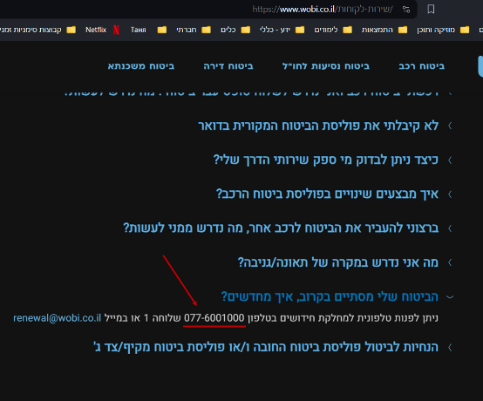



|  |  |  |  |
| --- | --- | --- | --- |
| [WS-12] Under "הורדת טפסים" a text right down logos of insurance companies seems to be clickable but it's not. Created: 08/Mar/24  Updated: 13/Mar/24 | | | |
| **Status:** | To Do | | |
| **Project:** | [Wobi_site](https://tatyanadman.atlassian.net/secure/BrowseProject.jspa?id=10004) | | |
| **Type:** | Bug | **Priority:** | Low |
| **Reporter:** | [Tatyana](https://tatyanadman.atlassian.net/secure/ViewProfile.jspa?accountId=626cfc5bb31e6f006864ef5b) | **Assignee:** | Unassigned |
| **Resolution:** | Unresolved | **Votes:** | 0 |
| **Environment:** | Desktop: Asus Vivobook.  OS: Windows 11.  Browser: Firefox  Version: 123.0.1 (64-bit) | | |
| **Attachments:** | p36.png | | |
| **Severity:** | S5 - Low | | |

|  |  |
| --- | --- |
| **Description** |  |

|  |
| --- |
| **Steps to Reproduce:**   1. Go to the site [www.wobi.co.il](https://www.wobi.co.il/) . 2. Navigate to “שירות לקוחות“. 3. Scroll down to “הורדת טפסים“. 4. Look at the text right down the logo of any company.   **Actual Result:**  The text is highlighted like a link and seems to be clickable.  **Expected Result:**  If a text should not be clickable it’s better not to highlight it same like a link. |

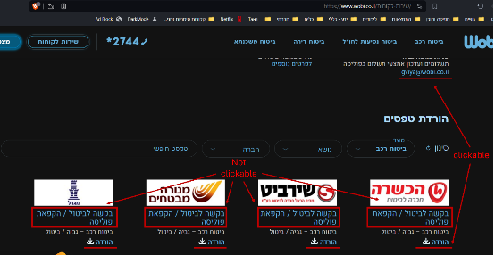



|  |  |  |  |
| --- | --- | --- | --- |
| [WS-13] The option “ביטוח נסיעות לחו”ל“ doesn’t appear at the drop box in the form under "?מעוניינים לקבל שיחה מנציג". Created: 08/Mar/24  Updated: 13/Mar/24 | | | |
| **Status:** | To Do | | |
| **Project:** | [Wobi_site](https://tatyanadman.atlassian.net/secure/BrowseProject.jspa?id=10004) | | |
| **Type:** | Bug | **Priority:** | High |
| **Reporter:** | [Tatyana](https://tatyanadman.atlassian.net/secure/ViewProfile.jspa?accountId=626cfc5bb31e6f006864ef5b) | **Assignee:** | Unassigned |
| **Resolution:** | Unresolved | **Votes:** | 0 |
| **Environment:** | Desktop: Asus Vivobook.  OS: Windows 11.  Browser: Firefox.  Version: 123.0.1 (64-bit). | | |
| **Attachments:** | p35.png | | |
| **Severity:** | S5 - Low | | |

|  |  |
| --- | --- |
| **Description** |  |

|  |
| --- |
| **Steps to Reproduce:**   1. Go to the site [www.wobi.co.il](https://www.wobi.co.il/) . 2. At the home page scroll down till the form “**?מעוניינים לקבל שיחה מנציג**“. 3. Open the drop box “נושא“. 4. Look for the option “ביטוח נסיעות לחו”ל“.   **Actual Result:**  The option “ביטוח נסיעות לחו”ל“ doesn’t appear at the drop box.  **Expected Result:**  The option should appear at the drop box. |

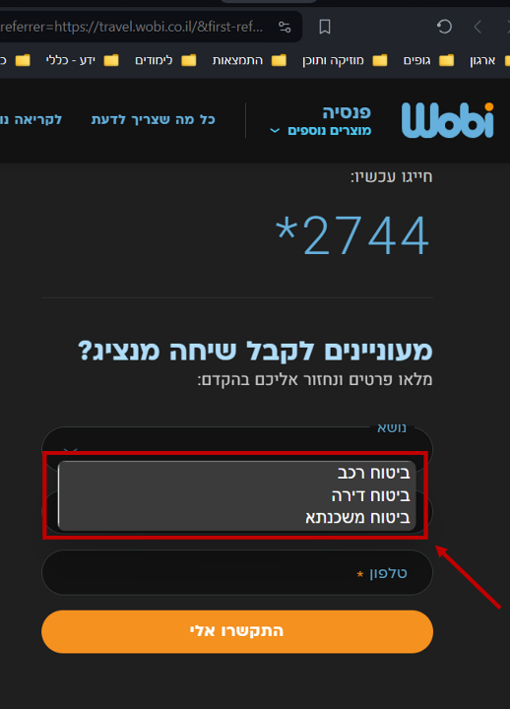



|  |  |  |  |
| --- | --- | --- | --- |
| [WS-14] The field "שם מלא" doesn't limit the number of characters that can be entered. Created: 08/Mar/24  Updated: 12/Mar/24 | | | |
| **Status:** | To Do | | |
| **Project:** | [Wobi_site](https://tatyanadman.atlassian.net/secure/BrowseProject.jspa?id=10004) | | |
| **Type:** | Bug | **Priority:** | Medium |
| **Reporter:** | [Tatyana](https://tatyanadman.atlassian.net/secure/ViewProfile.jspa?accountId=626cfc5bb31e6f006864ef5b) | **Assignee:** | Unassigned |
| **Resolution:** | Unresolved | **Votes:** | 0 |
| **Environment:** | Desktop: Asus Vivobook.  OS: Windows 11.  Browser: Firefox.  Version: 123.0.1 (64-bit). | | |
| **Attachments:** | p34.png | | |
| **Severity:** | S5 - Low | | |

|  |  |
| --- | --- |
| **Description** |  |

|  |
| --- |
| **Steps to Reproduce:**   1. Go to the site [www.wobi.co.il](https://www.wobi.co.il/) . 2. Press the “מצטרפים חדשים“ button. 3. At the “שם מלא“ field try to enter a string of 37000 letters (or any other number of letters). 4. Fill the rest of the fields with correct data and press the “התקשרו אלי“ button.   **Actual Result:**  It is possible to enter a non-limited number of characters into the field.  **Expected Result:**  The should be limit of characters that can be entered into the name field. Usually it’s about 255 characters. |

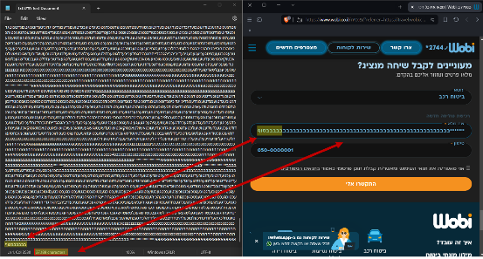



|  |  |  |  |
| --- | --- | --- | --- |
| [WS-15] The "שם מלא" field except a "name" consist of only spaces. Created: 08/Mar/24  Updated: 12/Mar/24 | | | |
| **Status:** | To Do | | |
| **Project:** | [Wobi_site](https://tatyanadman.atlassian.net/secure/BrowseProject.jspa?id=10004) | | |
| **Type:** | Bug | **Priority:** | High |
| **Reporter:** | [Tatyana](https://tatyanadman.atlassian.net/secure/ViewProfile.jspa?accountId=626cfc5bb31e6f006864ef5b) | **Assignee:** | Unassigned |
| **Resolution:** | Unresolved | **Votes:** | 0 |
| **Environment:** | Desktop: Asus Vivobook.  OS: Windows 11.  Browser: Firefox.  Version: 123.0.1 (64-bit). | | |
| **Attachments:** | p31.png     p32.png     p33.png | | |
| **Severity:** | S5 - Low | | |

|  |  |
| --- | --- |
| **Description** |  |

|  |
| --- |
| **Steps to Reproduce:**   1. Go to the site [www.wobi.co.il](https://www.wobi.co.il/) . 2. Press the “מצטרפים חדשים“ button. 3. At the “שם מלא“ field enter a name consists of spaces only. 4. Fill the rest of the fields with correct data and press the “התקשרו אלי“ button.   **Actual Result:**  It is possible to enter a name consists of only spaces into the field.  **Expected Result:**  It should be impossible to enter a name consists of only spaces into the field. |

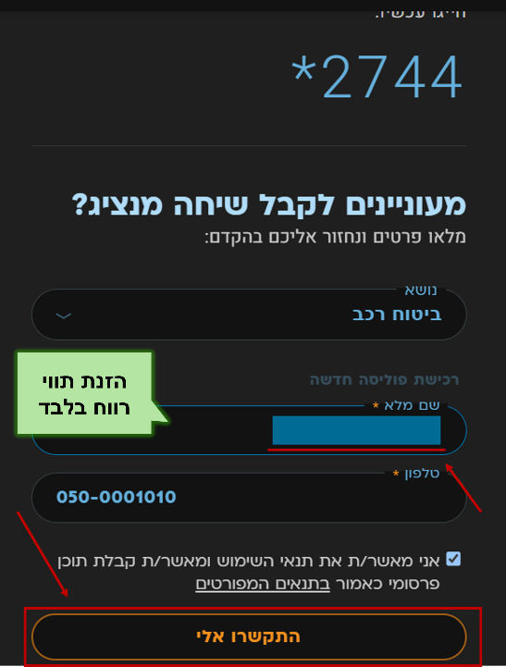

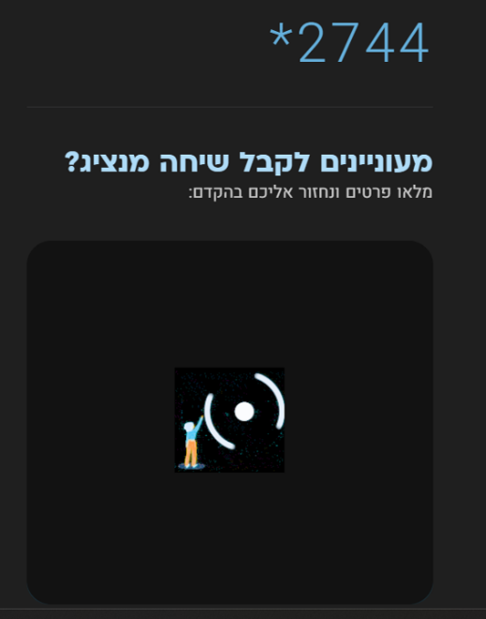

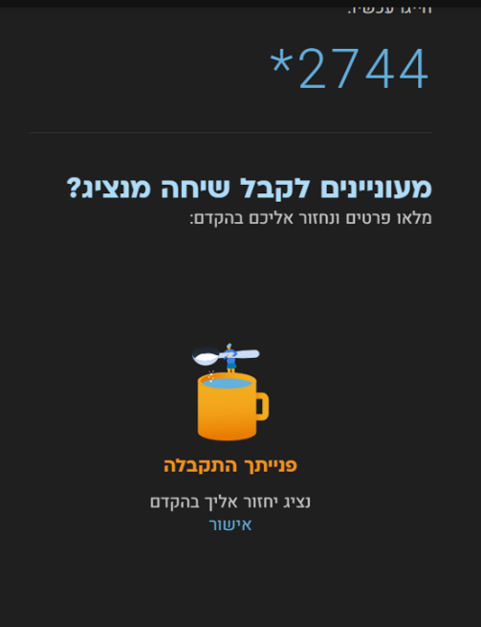



|  |  |  |  |
| --- | --- | --- | --- |
| [WS-16] There is no space between 2 words in the article "...הסחות דעת בזמן הנהיגה". Created: 09/Mar/24  Updated: 12/Mar/24 | | | |
| **Status:** | To Do | | |
| **Project:** | [Wobi_site](https://tatyanadman.atlassian.net/secure/BrowseProject.jspa?id=10004) | | |
| **Type:** | Bug | **Priority:** | Medium |
| **Reporter:** | [Tatyana](https://tatyanadman.atlassian.net/secure/ViewProfile.jspa?accountId=626cfc5bb31e6f006864ef5b) | **Assignee:** | Unassigned |
| **Resolution:** | Unresolved | **Votes:** | 0 |
| **Environment:** | Desktop: Asus Vivobook.  OS: Windows 11.  Browser: Firefox  Version: 123.0.1 (64-bit) | | |
| **Attachments:** | p19.png | | |
| **Severity:** | S5 - Low | | |

|  |  |
| --- | --- |
| **Description** |  |

|  |
| --- |
| **Steps to Reproduce:**   1. Go to the site [www.wobi.co.il](https://www.wobi.co.il/) . 2. Scroll down to the “footer“. 3. At the section “ביטוח רכב“ go to “לכותבות נוספות“. 4. Scroll down to the article “הסחות דעת בזמן הנהיגה - כל הדרכים להתמודד עם התופעה“ 5. Look at the first sentence, find the words “שלעונת החורף“.   **Actual Result:**  Two words are written without space.  **Expected Result:**  There should be space between words. |

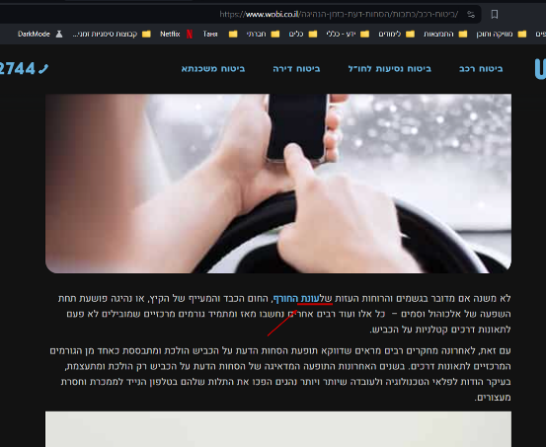



|  |  |  |  |
| --- | --- | --- | --- |
| [WS-17] Only a portion of the "צרו קשר" form is visible after clicking the link. Created: 09/Mar/24  Updated: 12/Mar/24 | | | |
| **Status:** | To Do | | |
| **Project:** | [Wobi_site](https://tatyanadman.atlassian.net/secure/BrowseProject.jspa?id=10004) | | |
| **Type:** | Bug | **Priority:** | Medium |
| **Reporter:** | [Tatyana](https://tatyanadman.atlassian.net/secure/ViewProfile.jspa?accountId=626cfc5bb31e6f006864ef5b) | **Assignee:** | Unassigned |
| **Resolution:** | Unresolved | **Votes:** | 0 |
| **Environment:** | Desktop: Asus Vivobook.  OS: Windows 11.  Browser: Firefox  Version: 123.0.1 (64-bit) | | |
| **Attachments:** | p30.png | | |
| **Severity:** | S5 - Low | | |

|  |  |
| --- | --- |
| **Description** |  |

|  |
| --- |
| **Steps to Reproduce:**   1. Go to the site [www.wobi.co.il](https://www.wobi.co.il/) . 2. Scroll down to the “footer“. 3. Click on “צרו קשר“ button.   **Actual Result:**  Here's a more beautiful way to rephrase the sentence:  Clicking the button takes you to the "?מעוניינים לקבל שיחה מנציג" form, however, only a portion of the form is visible while you can see irrelevant background content from another part of the page.  **Expected Result:**  The button direct you to the part of the page where the whole form is visible. |

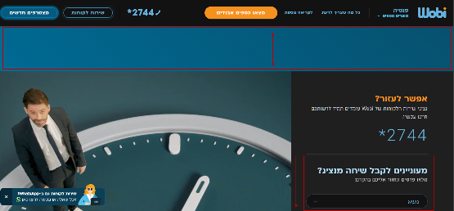



|  |  |  |  |
| --- | --- | --- | --- |
| [WS-18] Misleading "מצאו כספים אבודים" Button Navigation. Created: 09/Mar/24  Updated: 13/Mar/24 | | | |
| **Status:** | To Do | | |
| **Project:** | [Wobi_site](https://tatyanadman.atlassian.net/secure/BrowseProject.jspa?id=10004) | | |
| **Type:** | Bug | **Priority:** | Medium |
| **Reporter:** | [Tatyana](https://tatyanadman.atlassian.net/secure/ViewProfile.jspa?accountId=626cfc5bb31e6f006864ef5b) | **Assignee:** | Unassigned |
| **Resolution:** | Unresolved | **Votes:** | 0 |
| **Environment:** | Desktop: Asus Vivobook.  OS: Windows 11.  Browser: Firefox  Version: 123.0.1 (64-bit) | | |
| **Attachments:** | 29.png     p25.png     p26.png     p27.png     p28.png | | |
| **Severity:** | S5 - Low | | |

|  |  |
| --- | --- |
| **Description** |  |

|  |
| --- |
| **Steps To Reproduce:**   1. Go to the site [www.wobi.co.il](https://www.wobi.co.il/) . 2. Scroll down to the “footer“. 3. Click on “פנסיה“ link. 4. At the navigation bar click on the button “מצאו כספים אבודים“.   **Actual Result:**  Clicking the "מצאו כספים אבודים" (Find Lost Funds) button in the navigation bar leads to a regular article page on the same website. There is no form or functionality to directly help users find lost funds.  **Expected Result:**  Clicking the button should take users to a dedicated page or section with functionalities designed to help them locate lost funds. This could include:   * A search tool for unclaimed funds * Resources or links to external websites that specialize in recovering lost fund |

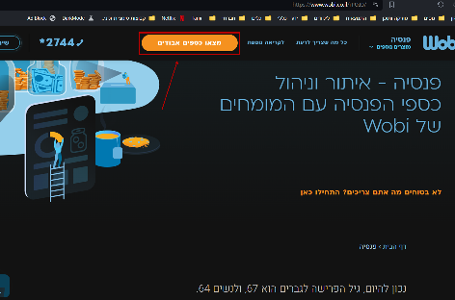

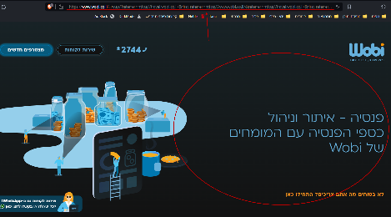

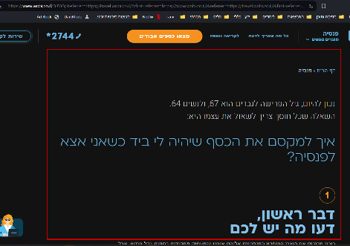

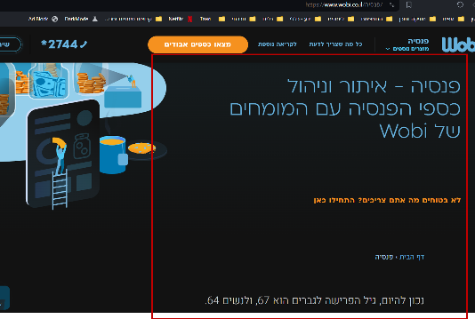

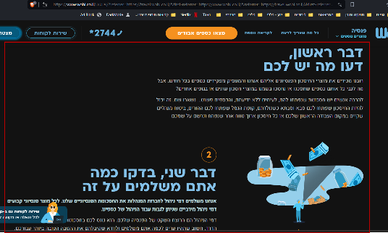



|  |  |  |  |
| --- | --- | --- | --- |
| [WS-19] "פנסיה" Link in Footer Leads to 502 Bad Gateway Error Created: 09/Mar/24  Updated: 12/Mar/24 | | | |
| **Status:** | To Do | | |
| **Project:** | [Wobi_site](https://tatyanadman.atlassian.net/secure/BrowseProject.jspa?id=10004) | | |
| **Type:** | Bug | **Priority:** | Highest |
| **Reporter:** | [Tatyana](https://tatyanadman.atlassian.net/secure/ViewProfile.jspa?accountId=626cfc5bb31e6f006864ef5b) | **Assignee:** | Unassigned |
| **Resolution:** | Unresolved | **Votes:** | 0 |
| **Environment:** | Desktop: Asus Vivobook.  OS: Windows 11.  Browser: Brave  Version: 1.61.109 | | |
| **Attachments:** | p20.png     p21.png | | |
| **Severity:** | S2 - Critical | | |

|  |  |
| --- | --- |
| **Description** |  |

|  |
| --- |
| **Steps to Reproduce:**   1. Go to the site [www.wobi.co.il](https://www.wobi.co.il/) . 2. Scroll down to the footer section. 3. Click on the link labeled "פנסיה".   **Actual Result:**  Upon clicking the link, a "502 Bad Gateway" error message appears in the browser. This indicates a communication error between the [www.wobi.co.il](https://www.wobi.co.il/) server and another server it relies on to display the "פנסיה" page. The bug was reproduced on 09.03.24 11:30 AM  **Expected Result:**  Clicking the "פנסיה" link should navigate the user to a dedicated page on [www.wobi.co.il](https://www.wobi.co.il/) that provides information about their pension products and services. |

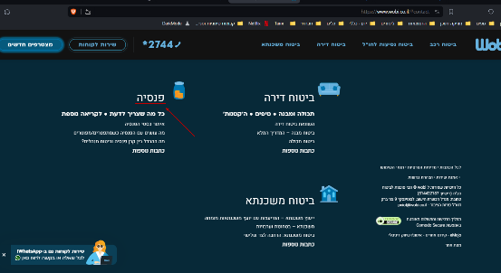

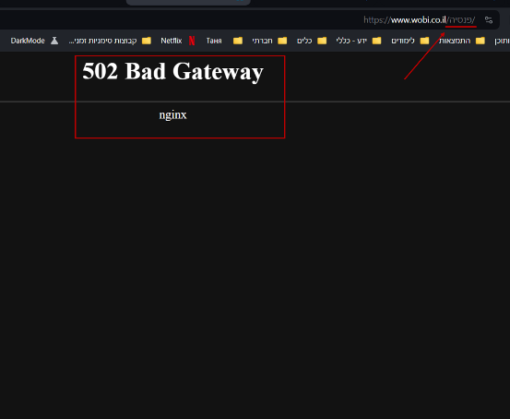



|  |  |  |  |
| --- | --- | --- | --- |
| [WS-20] Text Contrast Issue in Dark Mode Articles ("ביטוח רכב") Created: 09/Mar/24  Updated: 12/Mar/24 | | | |
| **Status:** | To Do | | |
| **Project:** | [Wobi_site](https://tatyanadman.atlassian.net/secure/BrowseProject.jspa?id=10004) | | |
| **Type:** | Bug | **Priority:** | Low |
| **Reporter:** | [Tatyana](https://tatyanadman.atlassian.net/secure/ViewProfile.jspa?accountId=626cfc5bb31e6f006864ef5b) | **Assignee:** | Unassigned |
| **Resolution:** | Unresolved | **Votes:** | 0 |
| **Attachments:** | p23.png     p24.png | | |
| **Severity:** | S3 - Major | | |
| **Environment:** | Desktop: Asus Vivobook.  OS: Windows 11.  Browser: Brave  Version: 1.61.109 | | |

|  |  |
| --- | --- |
| **Description** |  |

|  |
| --- |
| **Steps to Reproduce:**   1. Go to the site [www.wobi.co.il](http://www.wobi.co.il) and enable Dark Mode. 2. Navigate to the "ביטוח רכב" section. 3. Scroll down to the "כמה טיפים לפני שקונים ביטוח רכב" articles. 4. Observe the text in the forth and fifth articles.   **Actual Result:**  The text in the aforementioned articles is challenging to read due to the low contrast with the underlying images.  **Expected Result:**  The text and underlying images in the articles should exhibit sufficient contrast to ensure optimal readability in Dark Mode. |

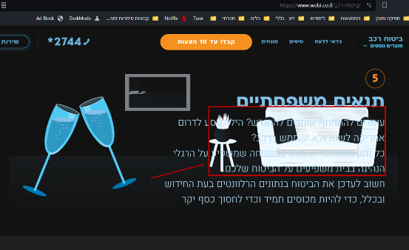

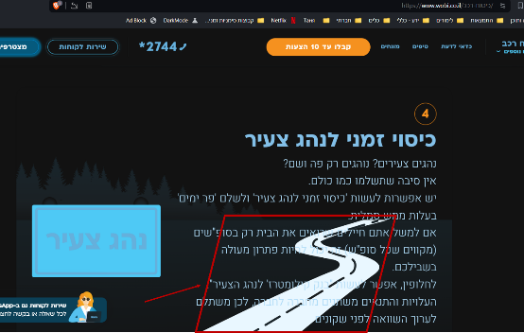



|  |  |  |  |
| --- | --- | --- | --- |
| [WS-21] There is a part of a list that separated from the rest of the text (ביטוח רכב > שאלות ותשובות). Created: 09/Mar/24  Updated: 09/Mar/24 | | | |
| **Status:** | To Do | | |
| **Project:** | [Wobi_site](https://tatyanadman.atlassian.net/secure/BrowseProject.jspa?id=10004) | | |
| **Type:** | Bug | **Priority:** | Medium |
| **Reporter:** | [Tatyana](https://tatyanadman.atlassian.net/secure/ViewProfile.jspa?accountId=626cfc5bb31e6f006864ef5b) | **Assignee:** | Unassigned |
| **Resolution:** | Unresolved | **Votes:** | 0 |
| **Environment:** | Desktop: Asus Vivobook.  OS: Windows 11.  Browser: Brave  Version: 1.61.109 | | |
| **Severity:** | S5 - Low | | |
| **Attachments:** | p23.png     p24.png | | |

|  |  |
| --- | --- |
| **Description** |  |

|  |
| --- |
| **Steps to Reproduce:**   1. Go to [Wobi.co.il](http://Wobi.co.il) and navigate to the "ביטוח רכב" section. 2. Locate the "שאלות ותשובות" section. 3. Find the article "אילו הרחבות קיימות בביטוח הרכב".   **Actual Result:**  The article provides a list of coverages; however, one coverage appears isolated from the main list, situated at the very end of the article. This disrupts the logical flow of the information.  **Expected Result:**  The answer to the question "אילו הרחבות קיימות בביטוח הרכב" should present a comprehensive and cohesive list of available coverages for car insurance. All coverages should be integrated seamlessly within the list, ensuring clear and consistent information for users |

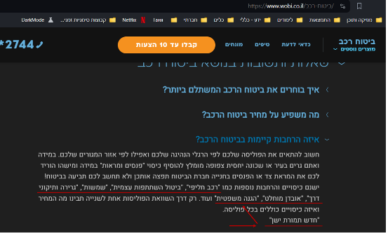



|  |  |  |  |
| --- | --- | --- | --- |
| [WS-22] The "מהיום" radio button is not functioning as expected (ביטוח רכב > מקיף + חובה). Created: 09/Mar/24  Updated: 09/Mar/24 | | | |
| **Status:** | To Do | | |
| **Project:** | [Wobi_site](https://tatyanadman.atlassian.net/secure/BrowseProject.jspa?id=10004) | | |
| **Type:** | Bug | **Priority:** | Medium |
| **Reporter:** | [Tatyana](https://tatyanadman.atlassian.net/secure/ViewProfile.jspa?accountId=626cfc5bb31e6f006864ef5b) | **Assignee:** | Unassigned |
| **Resolution:** | Unresolved | **Votes:** | 0 |
| **Environment:** | Desktop: Asus Vivobook.  OS: Windows 11.  Browser: Brave  Version: 1.61.109 | | |
| **Severity:** | S3 - Major | | |
| **Attachments:** | p47.png | | |

|  |  |
| --- | --- |
| **Description** |  |

|  |
| --- |
| **Steps to Reproduce:**   1. Go to the site [www.wobi.co.il](https://www.wobi.co.il/) . 2. Navigate to “ביטוח רכב“. 3. Select “מקיף + חובה“. 4. Try to choose the “מהיום“ option.   **Actual Result:**  The button is not clickable. The selection is not reflected visually and it has no impact on the system's functionality.  **Expected Result:**  The button should be responsive and clickable. |

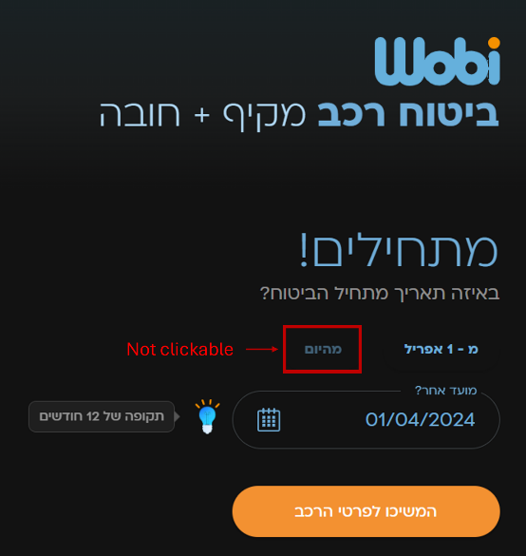



|  |  |  |  |
| --- | --- | --- | --- |
| [WS-23] Car brand search limited to Hebrew letters. Created: 09/Mar/24  Updated: 12/Mar/24 | | | |
| **Status:** | To Do | | |
| **Project:** | [Wobi_site](https://tatyanadman.atlassian.net/secure/BrowseProject.jspa?id=10004) | | |
| **Type:** | Bug | **Priority:** | Medium |
| **Reporter:** | [Tatyana](https://tatyanadman.atlassian.net/secure/ViewProfile.jspa?accountId=626cfc5bb31e6f006864ef5b) | **Assignee:** | Unassigned |
| **Resolution:** | Unresolved | **Votes:** | 0 |
| **Environment:** | Desktop: Asus Vivobook.  OS: Windows 11.  Browser: Brave  Version: 1.61.109 | | |
| **Attachments:** | p16.png     p17.png     p18.png | | |
| **Severity:** | S3 - Major | | |

|  |  |
| --- | --- |
| **Description** |  |

|  |
| --- |
| **Steps to Reproduce:**   1. Go to the site [www.wobi.co.il](https://www.wobi.co.il/) with Dark Mode. 2. Navigate to “ביטוח רכב“. 3. Select “מקיף + חובה“. 4. Fill all the forms till the “פרטי רכב“ page appears. 5. In the section “יצרן“ click the “עוד+“ button. 6. In appeared search line try to enter a car brand name in English characters.   **Actual Result:**  The car brand search functionality on the page only accepts input in Hebrew characters. Searching for car brands using English characters shows no results, even for brands with a well-established English name recognition.  **Expected Result:**  The car brand search function should be multilingual. Users should be able to enter car brand names in both Hebrew and English characters to achieve accurate search results. |

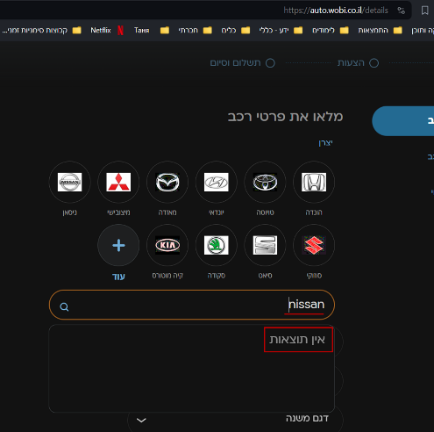

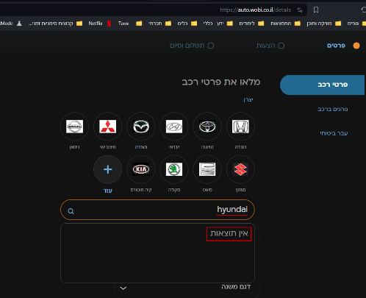

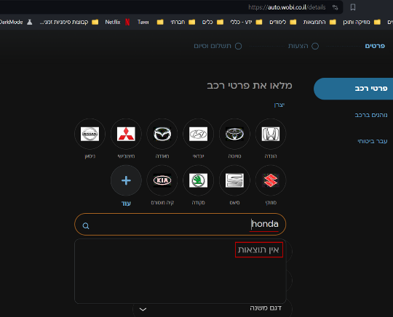



|  |  |  |  |
| --- | --- | --- | --- |
| [WS-24] In the "יצרן" section the list of car brands is not complete (ביטוח רכב). Created: 09/Mar/24  Updated: 12/Mar/24 | | | |
| **Status:** | To Do | | |
| **Project:** | [Wobi_site](https://tatyanadman.atlassian.net/secure/BrowseProject.jspa?id=10004) | | |
| **Type:** | Bug | **Priority:** | Medium |
| **Reporter:** | [Tatyana](https://tatyanadman.atlassian.net/secure/ViewProfile.jspa?accountId=626cfc5bb31e6f006864ef5b) | **Assignee:** | Unassigned |
| **Resolution:** | Unresolved | **Votes:** | 0 |
| **Environment:** | Desktop: Asus Vivobook.  OS: Windows 11.  Browser: Brave  Version: 1.61.109 | | |
| **Attachments:** | Screenshot 2024-03-12 160033.png     Screenshot 2024-03-12 160901.png     Screenshot 2024-03-12 160956.png     Screenshot 2024-03-12 162423.png     Screenshot 2024-03-12 162449.png | | |
| **Severity:** | S3 - Major | | |



|  |  |
| --- | --- |
| **Description** |  |

|  |
| --- |
| **Steps to Reproduce:**   1. Go to the site [www.wobi.co.il](https://www.wobi.co.il/) . 2. Navigate to “ביטוח רכב“. 3. Select “מקיף + חובה“. 4. Fill all the forms till the “פרטי רכב“ page appears. 5. In the section “יצרן“ click the “עוד+“ button. 6. In appeared search line try to search for the following car brands: EVEASY, WEY, אורה, איסוזו, איווקו, אלפין, אקספנג, האמר, וויה, זיקר, לינק אנד קו, לנדרובר, מאן ,מיני, ניו, פונטיאק, צ'רי.  * נכון ל08.03.24. הרשימה של יצרנים באתר משתנה.   **Actual Result:**  A lot of car brands are not presented in the list of “יצרן“. Such as,  EVEASY, WEY, אורה, איסוזו, איווקו, אלפין, אקספנג, האמר, וויה, זיקר, לינק אנד קו, לנדרובר, מאן ,מיני, ניו, פונטיאק, צ'רי.  Also there is no any message that explain why certain car brands are not available to choose.  **Expected Result:**  There should be available to choose all the popular/presented in Israel car brands. In case that some brands are not available there should be any explanation of the reason. |

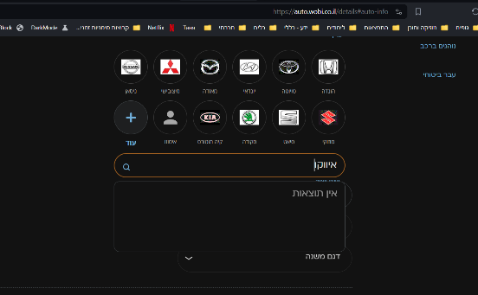

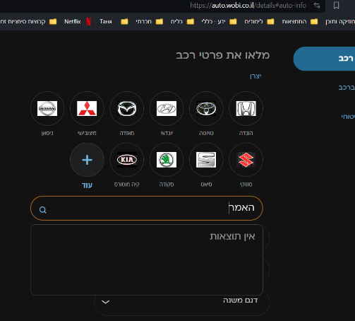

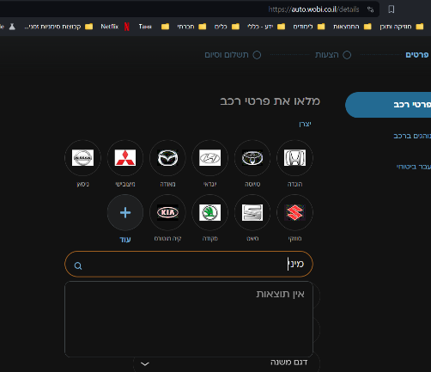



|  |  |  |  |
| --- | --- | --- | --- |
| [WS-25] Inaccurate error message in travel insurance end date field. Created: 12/Mar/24  Updated: 12/Mar/24 | | | |
| **Status:** | To Do | | |
| **Project:** | [Wobi_site](https://tatyanadman.atlassian.net/secure/BrowseProject.jspa?id=10004) | | |
| **Type:** | Bug | **Priority:** | Low |
| **Reporter:** | [Tatyana](https://tatyanadman.atlassian.net/secure/ViewProfile.jspa?accountId=626cfc5bb31e6f006864ef5b) | **Assignee:** | Unassigned |
| **Resolution:** | Unresolved | **Votes:** | 0 |
| **Environment:** | Desktop: Asus Vivobook.  OS: Windows 11.  Browser: Brave  Version: 1.61.109 | | |
| **Attachments:** | p12.png     p13.png     p14.png     p15.png | | |
| **Severity:** | S5 - Low | | |

|  |  |
| --- | --- |
| **Description** |  |

|  |
| --- |
| **Steps to Reproduce:**   1. Go to the site [www.wobi.co.il](https://www.wobi.co.il/) . 2. Navigate to “ביטוח נסיעות לחו”ל“. 3. Select “טוסו לחסוך“. 4. At the field “סיום הנסיעה“ enter the following invalid data and press the button “המשך“:    1. a date in the past    2. a date far in the future    3. a non-existent date (e.g., 13th month or 32nd day of the month)   **Actual Result:**  When a user enters an invalid date in the travel insurance end date field, the system displays the same generic error message ("זמן הביטוח עד 180 ימים") regardless of the specific error. This could be triggered by entering:  A date in the past (past travel)  A date far in the future (more than 10 years)  A non-existent date (e.g., 13th month or 32nd day of the month)  **Expected Result:**  The system should display specific error messages tailored to the type of invalid date entered. This can include:  For past dates: "Travel insurance cannot be purchased for past travel dates. Please enter a future date."  For dates exceeding the maximum coverage: "The maximum travel insurance coverage is 180 days. Please enter a date within this limit."  For non-existent dates: "Please enter a valid date. The month has a maximum of 31 days." |

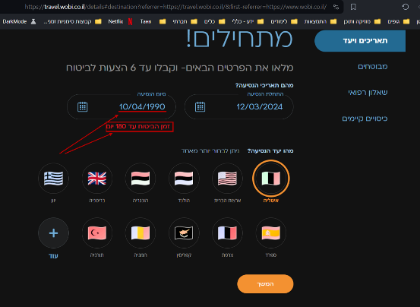

****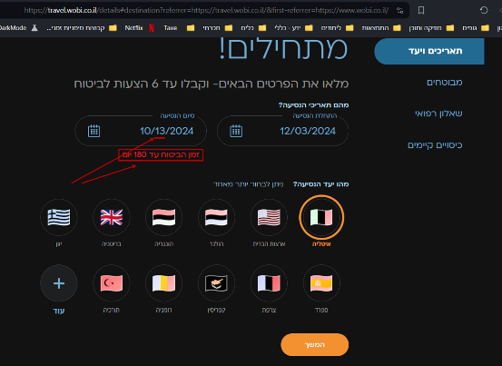

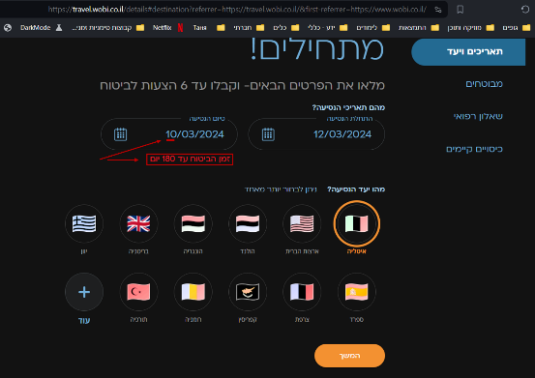

****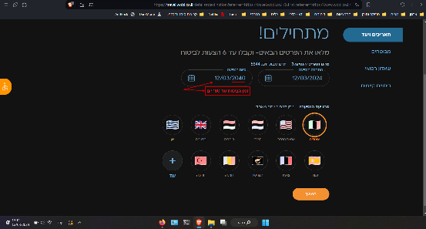



|  |  |  |  |  |
| --- | --- | --- | --- | --- |
| [WS-26] [Spelling error in "לאו קוסט" inside "ביטוח כבודה ב-2023" of the section "ביטוח נסיעות לחו"ל".](https://tatyanadman.atlassian.net/browse/WS-26) Created: 18/Mar/24  Updated: 18/Mar/24 | | | | |
| **Status:** | | To Do | | |
| **Project:** | | [Wobi_site](https://tatyanadman.atlassian.net/secure/BrowseProject.jspa?id=10004) | | |
| **Type:** | | Bug | **Priority:** | Low |
| **Reporter:** | | [Tatyana](https://tatyanadman.atlassian.net/secure/ViewProfile.jspa?accountId=626cfc5bb31e6f006864ef5b) | **Assignee:** | Unassigned |
| **Resolution:** | | Unresolved | **Votes:** | 0 |
| **Environment:** | | Desktop: Asus Vivobook.  OS: Windows 11.  Browser: Brave  Version: 1.61.109  Browser: Firefox.  Version: 123.0.1 (64-bit). | | |
| **Attachments:** | | p49.png | | |
| **Severity:** | | S5 - Low | | |
| **Description** | |  | | | |

|  |
| --- |
| **Steps to Reproduce:**   1. Go to the site [www.wobi.co.il](https://www.wobi.co.il/) . 2. Navigate to “ביטוח נסיעות לחו”ל“ at the bottom of the home page. 3. Select “ביטוח כבודה ב-2023“. 4. At the opened article scroll down to “האם צריך להשוות מחירים סעיפי ביטוח כבודה“. 5. Look at the clickable text “ביטוח כבודה לאו קוסט“.   **Actual Result:**  It spelled "לאו קוסט".  **Expected Result:**  It should be spelled “לואו קוסט“. |



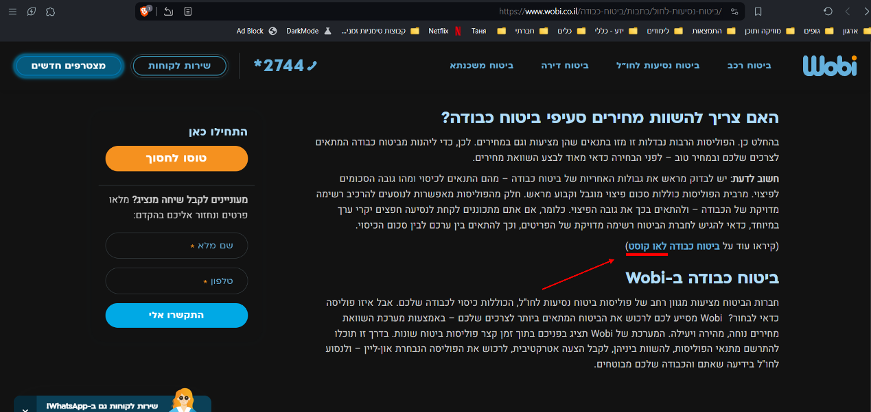

|  |  |  |  |  |
| --- | --- | --- | --- | --- |
| [WS-27] [Font failure at the footer.](https://tatyanadman.atlassian.net/browse/WS-27) Created: 18/Mar/24  Updated: 18/Mar/24 | | | | |
| **Status:** | | To Do | | |
| **Project:** | | [Wobi_site](https://tatyanadman.atlassian.net/secure/BrowseProject.jspa?id=10004) | | |
| **Type:** | | Bug | **Priority:** | High |
| **Reporter:** | | [Tatyana](https://tatyanadman.atlassian.net/secure/ViewProfile.jspa?accountId=626cfc5bb31e6f006864ef5b) | **Assignee:** | Unassigned |
| **Resolution:** | | Unresolved | **Votes:** | 0 |
| **Environment:** | | This bug was reproduced only in the following environment:  Desktop: Asus Vivobook.  OS: Windows 11.  Browser: Brave  Version: 1.61.109 | | |
| **Attachments:** | | p48.png | | |
| **Severity:** | | S5 - Low | | |
| **Description** | |  | | | |

|  |
| --- |
| **Steps to Reproduce:**   1. Go to the site [www.wobi.co.il](https://www.wobi.co.il/) . 2. Scroll down to the bottom of the page. 3. Look at the text columns.   **Actual Result:**  There is font error at the text - symbol of dot between words replaced by special signs.  **Expected Result:**  It should be shown as planned - dots between subtitles. |



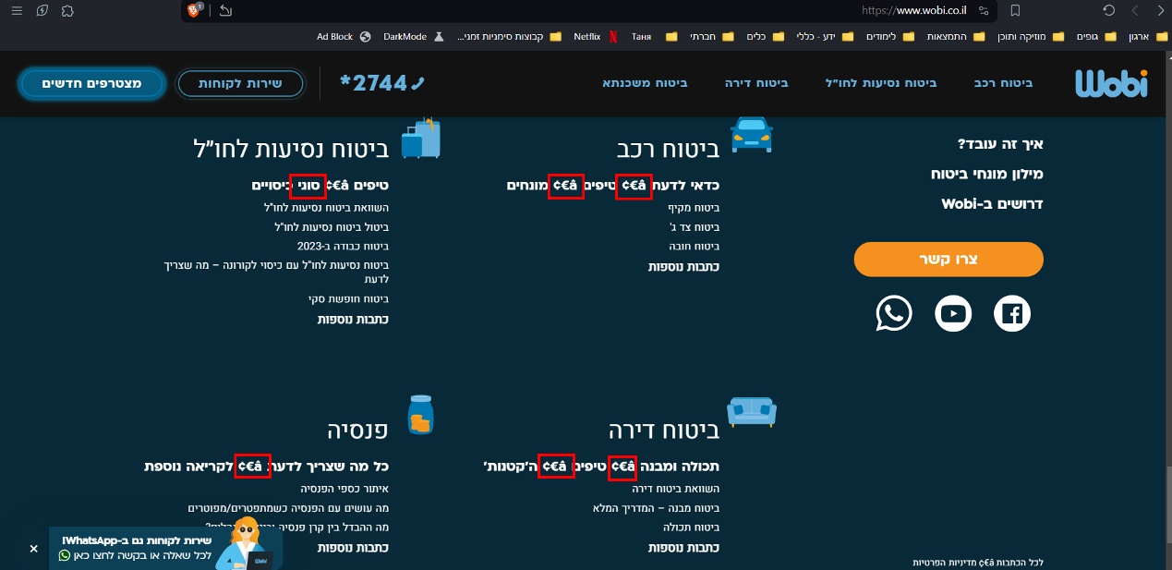



|  |  |  |  |  |
| --- | --- | --- | --- | --- |
| [WS-28] [There is unclear (unknown) direction in the section "תאריכים ויעד" of "ביטוח נסיעות לחו"ל".](https://tatyanadman.atlassian.net/browse/WS-28) Created: 18/Mar/24  Updated: 18/Mar/24 | | | | |
| **Status:** | | To Do | | |
| **Project:** | | [Wobi_site](https://tatyanadman.atlassian.net/secure/BrowseProject.jspa?id=10004) | | |
| **Type:** | | Bug | **Priority:** | High |
| **Reporter:** | | [Tatyana](https://tatyanadman.atlassian.net/secure/ViewProfile.jspa?accountId=626cfc5bb31e6f006864ef5b) | **Assignee:** | Unassigned |
| **Resolution:** | | Unresolved | **Votes:** | 0 |
| **Environment:** | | Desktop: Asus Vivobook.  OS: Windows 11.  Browser: Brave  Version: 1.61.109  Browser: Firefox.  Version: 123.0.1 (64-bit). | | |
| **Attachments:** | | p50.png     p51.png | | |
| **Severity:** | | S5 - Low | | |
| **Description** | |  | | | |

|  |
| --- |
| **Steps to Reproduce:**   1. Go to the site [www.wobi.co.il](https://www.wobi.co.il/) . 2. Navigate to “ביטוח נסיעות לחו”ל“. 3. Select “טוסו לחסוך“. 4. In “מהו יעד הנסיעה“ click on “עוד“ button. 5. In the search field start to enter “אבח“.   **Actual Result:**  In the results of search appears “אבחזיסטאן“ - unknown place.  **Expected Result:**  It should be only known and popular places. Should not be a situation that a user even doesn’t understand what country it is - if אבחזיסטאן is אבחזיה or any other place. |



